Problem 4. ALIENS

Aliens visited our planet with an obvious intention to find some new species for their space zoo. After entering Earth's orbit, they positioned themselves over the town of Belgrade, having detected some life-form activity on the ground. As they approached the surface, they saw a group of half-intelligent beings. Those creatures were actually competitors of the Balkan Olympiad in Informatics who were enjoying the excursion after intense contest. Aliens want to abduct all n (2 ≤ n ≤ 100000) competitors since they are very compassionate, and don’t want their creatures to feel lonely in the space zoo.
Aliens use tractor beam to take their prey. Tractor beam works in the following way: it projects a circle-shaped beam from the spacecraft to the ground vertically beneath it, and all beings that are found in that circle or on its boundary are taken. Projecting the tractor beam needs a certain amount of energy to be spent. As the radius of the tractor beam (radius of the circle on the ground) increases, more and more energy is required. Although extremely intelligent, aliens are much more advanced in social sciences than in programming. That’s why they are asking you to help them find the position of their spacecraft so that the energy required to take all of the n competitors is minimal.
Help our alien brothers! Write a program ZAD4.EXE that will find the required minimal radius of tractor beam that contains all n competitors, and the optimal spacecraft location, which is the same as the center of the circle on the ground.

INPUT: In the first line of input file ZAD4.DAT there is a single integer n. Each of next n lines contains two real numbers x_{i} and y_{i} (-10000.0 ≤ x_{i}, y_{i} ≤ 10000.0) representing the coordinates of i-th competitor.

OUTPUT: The output file ZAD4.RES contains two lines. In the first line there is single real number, radius of the tractor beam. Second line contains two real number, x and y coordinates of the spacecraft.
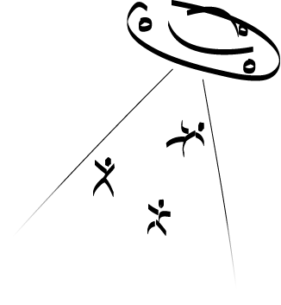
EXAMPLE:

ZAD4.DAT ZAD4.RES
6 5.00
8.0 9.0 5.00 5.00
4.0 7.5
1.0 2.0
5.1 8.7
9.0 2.0
4.5 1.0

All real numbers in the input file will be given using decimal notation (not exponential). The same is required for real numbers in the output file. Real numbers in the output file should be written with two decimal places, and both must be correct.

